**Project Development phase**

**Project Development delivery of sprint 4**

|  |  |
| --- | --- |
| Team ID | PNT2022TMID50833 |
| Project name | Plasma donorapplication |

**Architecture:**

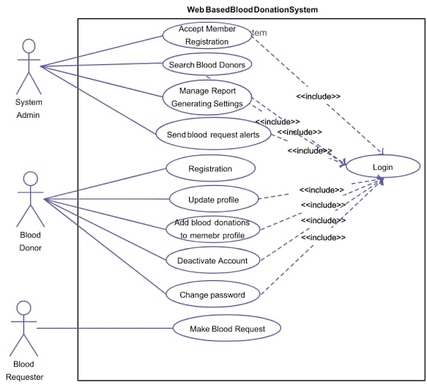

**Application features:**

* Proper medical authentication of plasma donors.
* Proper medical authentication of plasma recipient.
* Location and blood group based result.
* Donor & recipient communication platform.
* Video call & chat feature.
* Post sharing, commenting and contacting.
* Providing information & facts about blood & plasma donation.
* Few regional languages support.